KBE Notes

Inhoud

UML overview 2

Assembly 2

Higher Level Primitive 2

Capability module 2

# UML overview

See UML class diagram below

## Assembly

Class that gathers sizing data for relevant lifting surfaces and then either creates an assembly of HLP wing trunks to create the surfaces.

1. WingAssembly
2. Tail can either be:
   1. Conventional/Cruciform/T-tail
   2. H-tail/C-tail
   3. V-tail

## Higher Level Primitive

Classes that generate geometry based on parameter inputs.

1. Fuselage
2. Engine
3. WingTrunk

## Capability module

Classes that compute relevant data

1. Area
2. Weight
3. Aerodynamic
   1. Lift Gradients
   2. Downwash gradients
   3. Aerodynamic center
   4. Mean Aerodynamic Chord
4. Tail sizing
5. Wing positioning
6. Rudder blanketing
7. Deep stall
8. Xfoil output
9. Catia output
10. PDF output
    1. Trimetric view (drawing)
    2. Pdf from xfoil with airfoil + CL-alpha plot + CL_max + alpha_stall
    3. All input values and computed
11. Q3D output

# Capability module description

## Aerodynamic module

The aerodynamic module calculates various aerodynamic properties of the created model:

* Lift Gradients
  + Wing CL_alpha_w
  + Fuselage-wing combination CL_alpha_wf
  + Horizontal tailplane CL_alpha_h
* Downwash gradients
* Aerodynamic center
* Mean Aerodynamic Chord

### Lift gradients

For the wing:

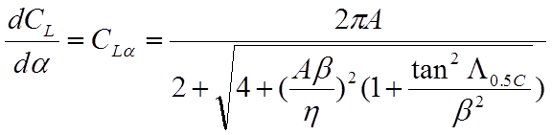





Note: units [1/Rad]

For the Fuselage-wing combination:

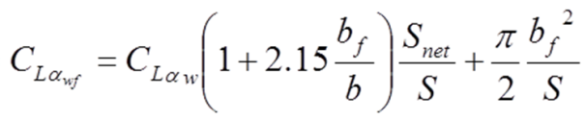

Note: CLalphaw = CLalpha above

Note: bf and S_net (S minus projection of central wing part) according to picture below:

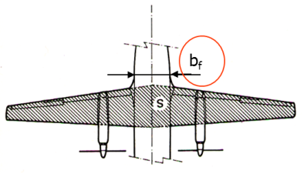

For the horizontal tailplane:

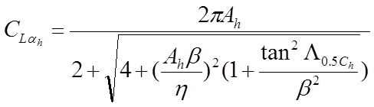



Note: Same formula as for the wing, however Mach number should take into account that speed is lower due to fuselage:

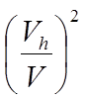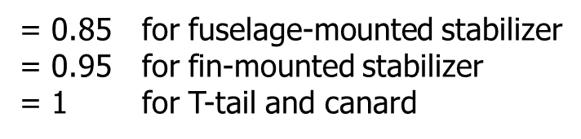

Note: in case of H-tail Ah can be increased by 1.5

### Downwash gradients

Wing downwash gradient can be calculated by:

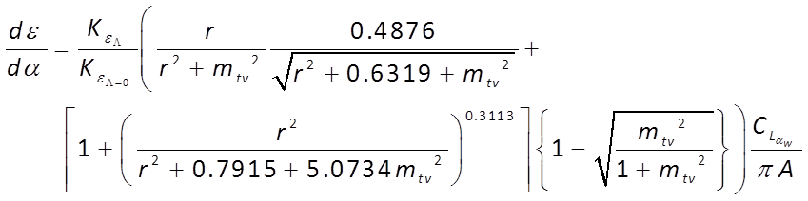

Where the two Kε terms accounting for the wing sweep angle effect (Λ expressed in radians) are defined as follow:

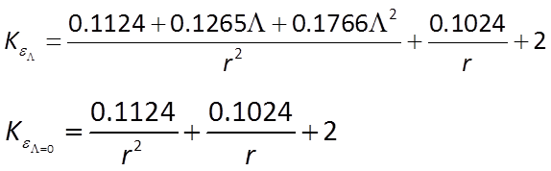

Mtv and r from:

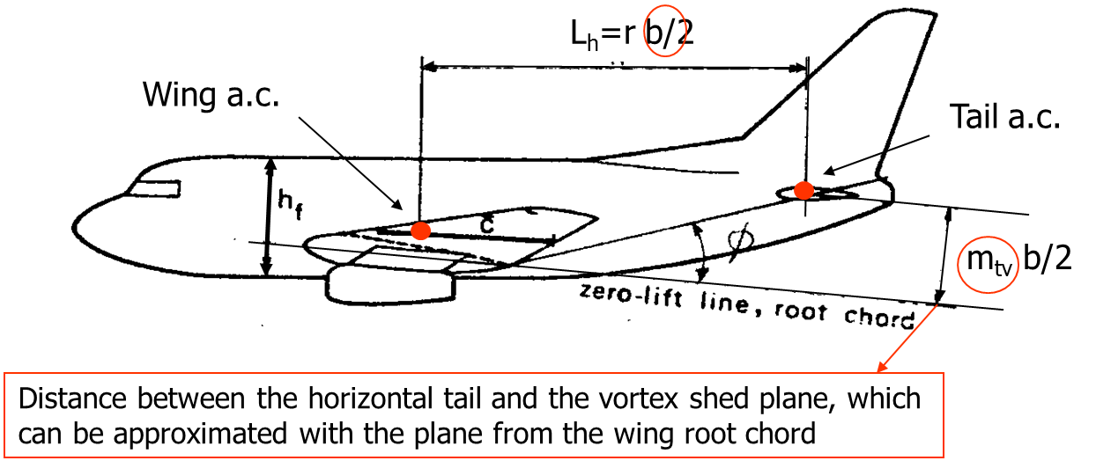

## Tail Sizing

Tail sizing is done via the tail volume coefficient method (statistics-based)

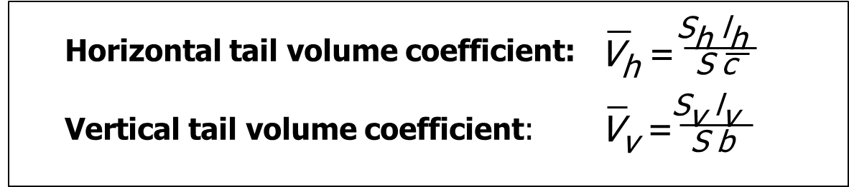

The tail arms lh and lv are the distances between the aerodynamic centers of wing and horizontal tail, and vertical tail, respectively. They can be approximated by distances between the mean quarter-chord points of the wing and tailplanes mean aerodynamic chords.

Since the tail design follows the fuselage and wing design, and since, it is logical to position the vertical tail empennages as far back as possible on the fuselage (to maximize the effective arm), the values of the tail arms are actually known. Hence, by means of the tail volume coefficients and the wing planform data (wing planform area and mean aerodynamic chord and span), the planform area of the tail empennages can be immediately estimated.

The name tail “volume” coefficient just follows by its definition: it is the product of the (tail empennage) area times the (tail arm) length, hence a volume! Such volume is then normalized using the product of wing area and wing MAC (or wing span).

The size of the aircraft, the type and number of engines and their position (e.g. wing podded, embedded in the fuselage or attached at the back of the fuselage) have an influence on the tail size. Hence use tail volume coefficients of appropriate reference aircraft!!

A collection of tail volume values for various jet transport aircraft is provided in this package. See below:

Table : horizontal tail volume data

|  |  |  |  |  |  |  |  |  |
| --- | --- | --- | --- | --- | --- | --- | --- | --- |
| # engines | engine mounting | Tail type | Aircraft | 2 |  |  | Lh [ft] |  |
|  |  | T | Boeing 727-200 | 1700 | 18.0 | 376 | 67.0 | 0.82 |
|  |  | Con | Boeing 737-200 | 980 | 11.2 | 321 | 43.8 | 1.28 |
|  |  | Con | Boeing 737-300 | 1117 | 10.9 | 390 | 49.7 | 1.35 |
|  |  |  | Boeing 747-200B | 5500 | 38.0 | 1470 | 104.5 | 0.74 |
|  |  |  | Boeing 747SP | 5500 | 38.0 | 1534 | 72.9 | 0.54 |
|  |  |  | Boeing 757-200 | 1951 | 14.9 | 585 | 56.9 | 1.15 |
|  |  |  | Boeing 767-200 | 3050 | 19.8 | 836 | 67.6 | 0.94 |
|  |  |  | McDonnell Douglas DC-9-30 | 1270 | 15.7 | 314 | 61.4 | 0.96 |
|  |  |  | McDonnell Douglas DC-9-50 | 1001 | 11.8 | 276 | 56.8 | 1.32 |
|  |  |  | McDonnell Douglas DC-10-30 | 3958 | 24.7 | 1338 | 65.9 | 0.90 |
|  |  |  | Airbus A300B4 | 2799 | 19.2 | 748 | 80.4 | 1.12 |
|  |  |  | Airbus A310 | 2357 | 19.9 | 689 | 72.0 | 1.09 |
|  |  |  | Lockheed L1011-500 | 3541 | 24.5 | 1282 | 55.9 | 0.83 |
|  |  |  | Fokker F-28-4000 | 850 | 10.9 | 210 | 47.2 | 1.07 |
|  |  |  | BAC 1-11 495 | 1031 | 11.8 | 258 | 40.7 | 0.86 |
|  |  |  | BAe 146-200 | 832 | 20.2 | 276 | 45.3 | 1.48 |
|  |  |  | Tupolev Tu-154 | 2169 | 16.7 | 436 | 58.9 | 0.71 |

## Wing positioning module

Module that does a first design iteration to determine the longitudinal position of the wing w.r.t. fuselage.

* Aircraft with wing podded engines have their wing positioned such that the aerodynamic center is located at 50% of the cylindrical part of the fuselage.
* Aircraft with aft-fuselage-mounted engines, have their wing a.c. around 60% of the cylindrical part of the fuselage (hence a bit after).

